Java Collections Framework — Detailed Tutorial
The Java Collections Framework (JCF) is a unified architecture for storing and manipulating groups of objects. It provides interfaces, implementations, and algorithms that allow developers to manage data efficiently.
Typical uses:
- Storing lists of objects
- Searching and sorting
- Removing duplicates
- Mapping keys to values

1. Java Collections Framework Architecture
The framework is organized into interfaces → implementations.
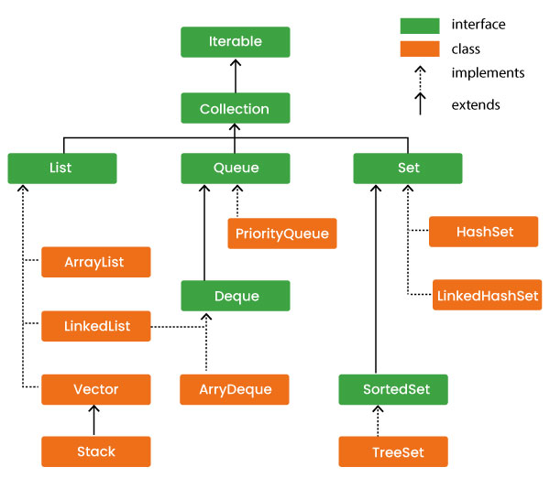
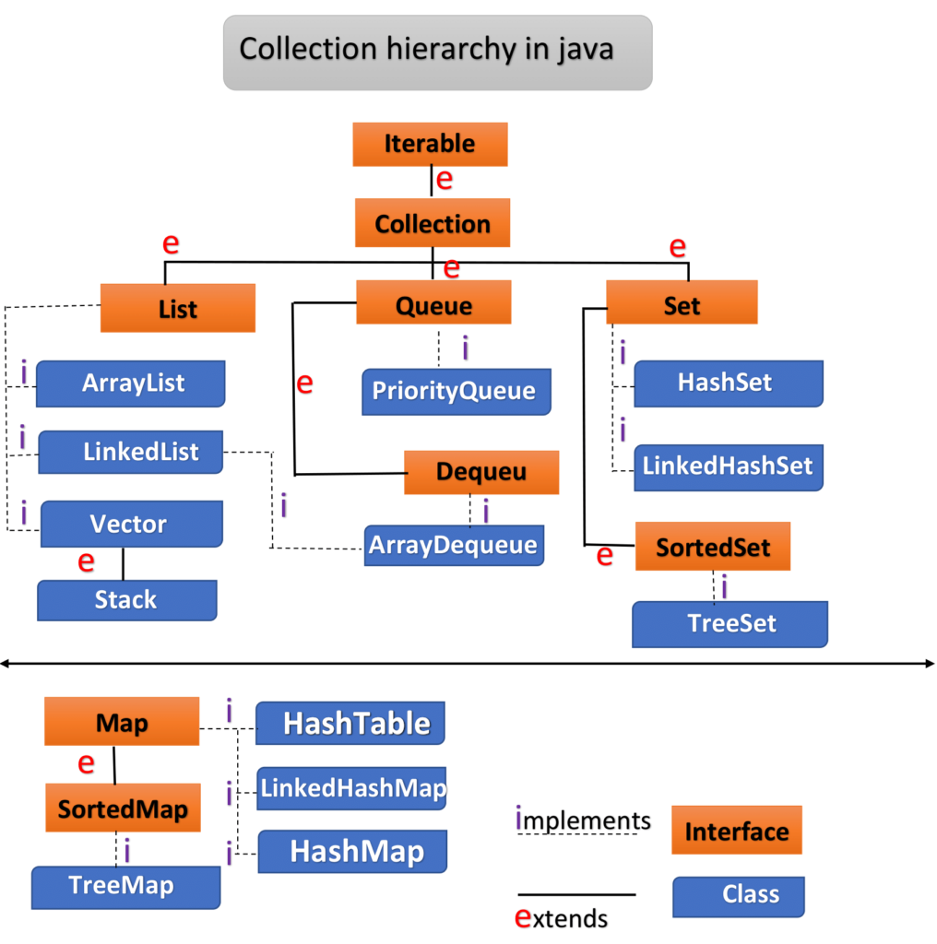
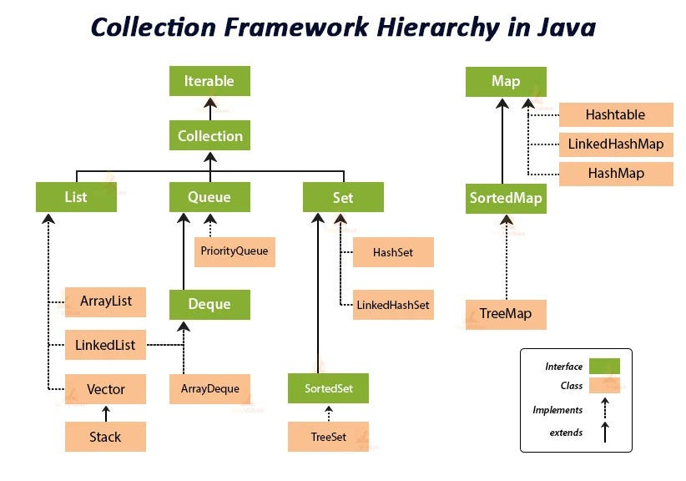
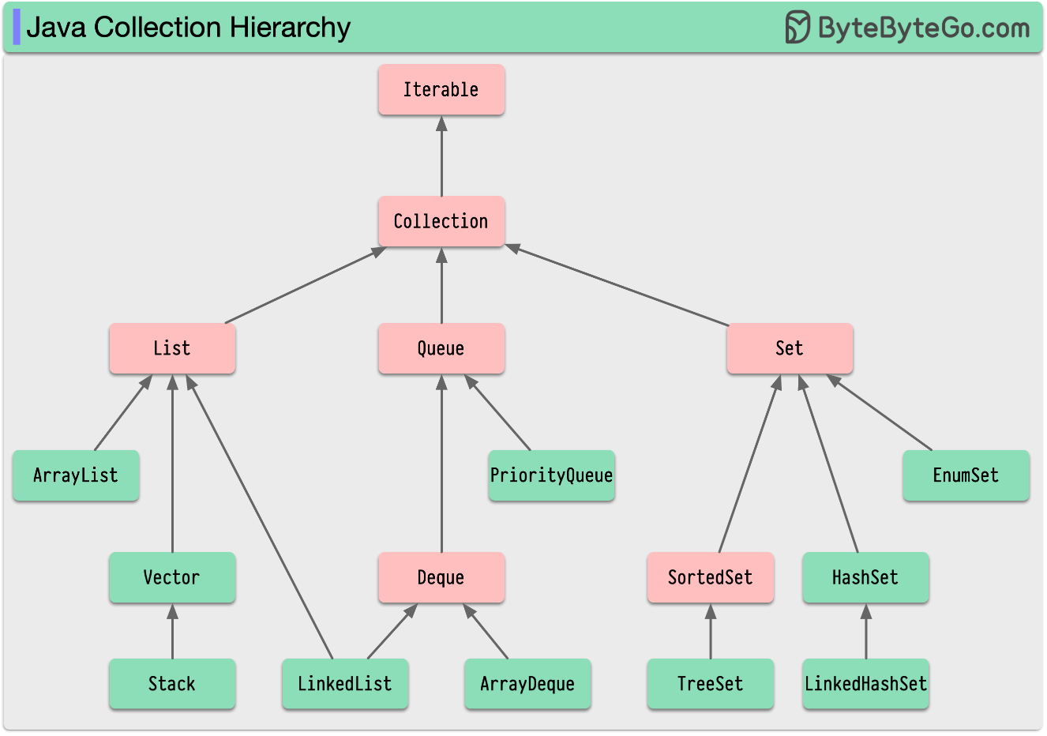

Core Interfaces
Interface | Description
Collection | Root interface of most collections
List | Ordered collection
Set | Unique elements only
Queue | FIFO structure
Map | Key-value pairs

2. Collection Interface
Collection is the root interface for most Java collections.
Key methods:
add()
remove()
size()
clear()
contains()
isEmpty()
iterator()

Example
import java.util.*;

public class CollectionExample {
public static void main(String[] args) {

Collection<String> fruits = new ArrayList<>();

fruits.add("Apple");
fruits.add("Mango");
fruits.add("Banana");

System.out.println(fruits);
}
}
Output
[Apple, Mango, Banana]

3. List Interface
A List is an ordered (insertion) collection that allows duplicates.
Implementations:
- ArrayList
- LinkedList
- Vector
- Stack

List Structure

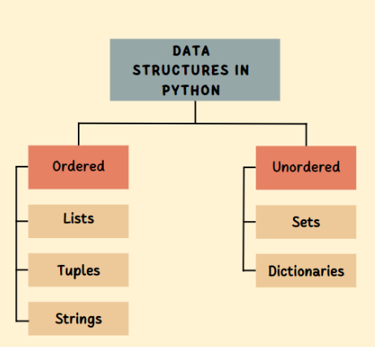
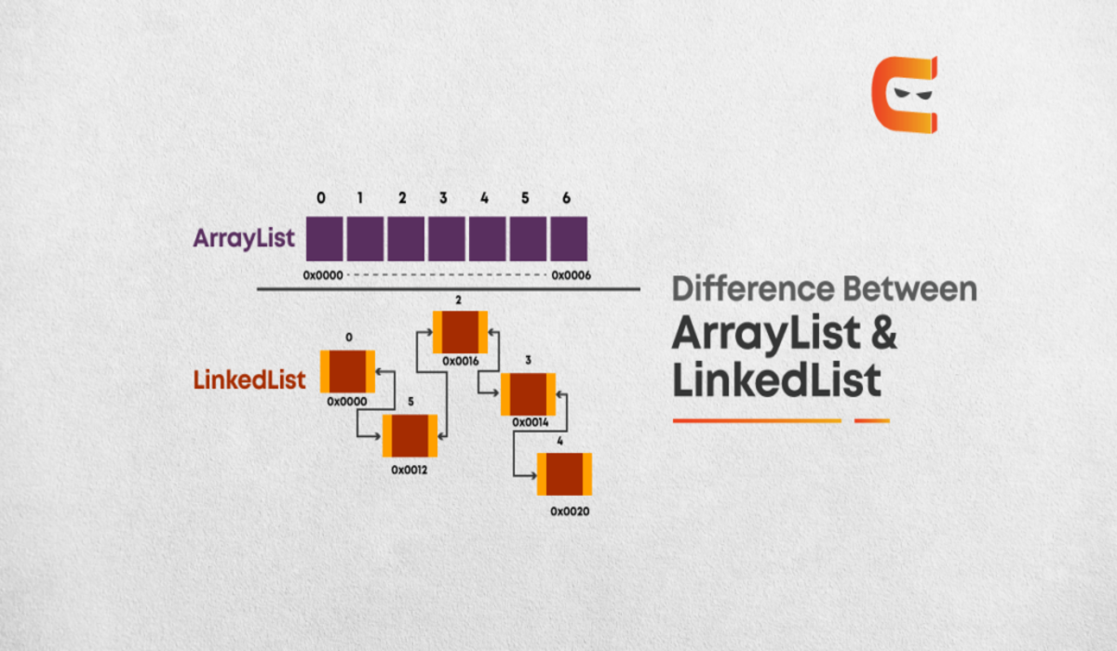
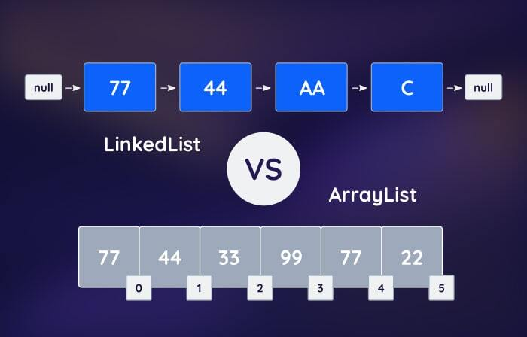

3.1 ArrayList
ArrayList is implemented using a dynamic array.

Characteristics
- Fast random access
- Allows duplicates
- Maintains insertion order

Example
import java.util.*;

public class ArrayListExample {

public static void main(String[] args) {

ArrayList<String> list = new ArrayList<>();

list.add("Java");
list.add("Python");
list.add("C++");

System.out.println(list);

System.out.println(list.get(1));

list.remove("Python");

System.out.println(list);
}
}
Output
[Java, Python, C++]
Python
[Java, C++]

3.2 LinkedList
Uses doubly linked list.

Characteristics
- Fast insertions/deletions
- Slower random access
- Memory overhead due to pointers

LinkedList Diagram
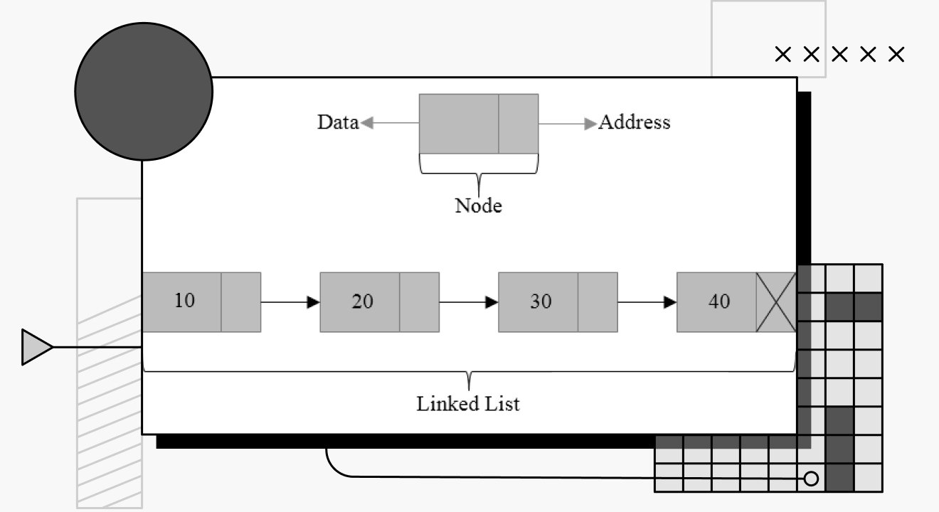
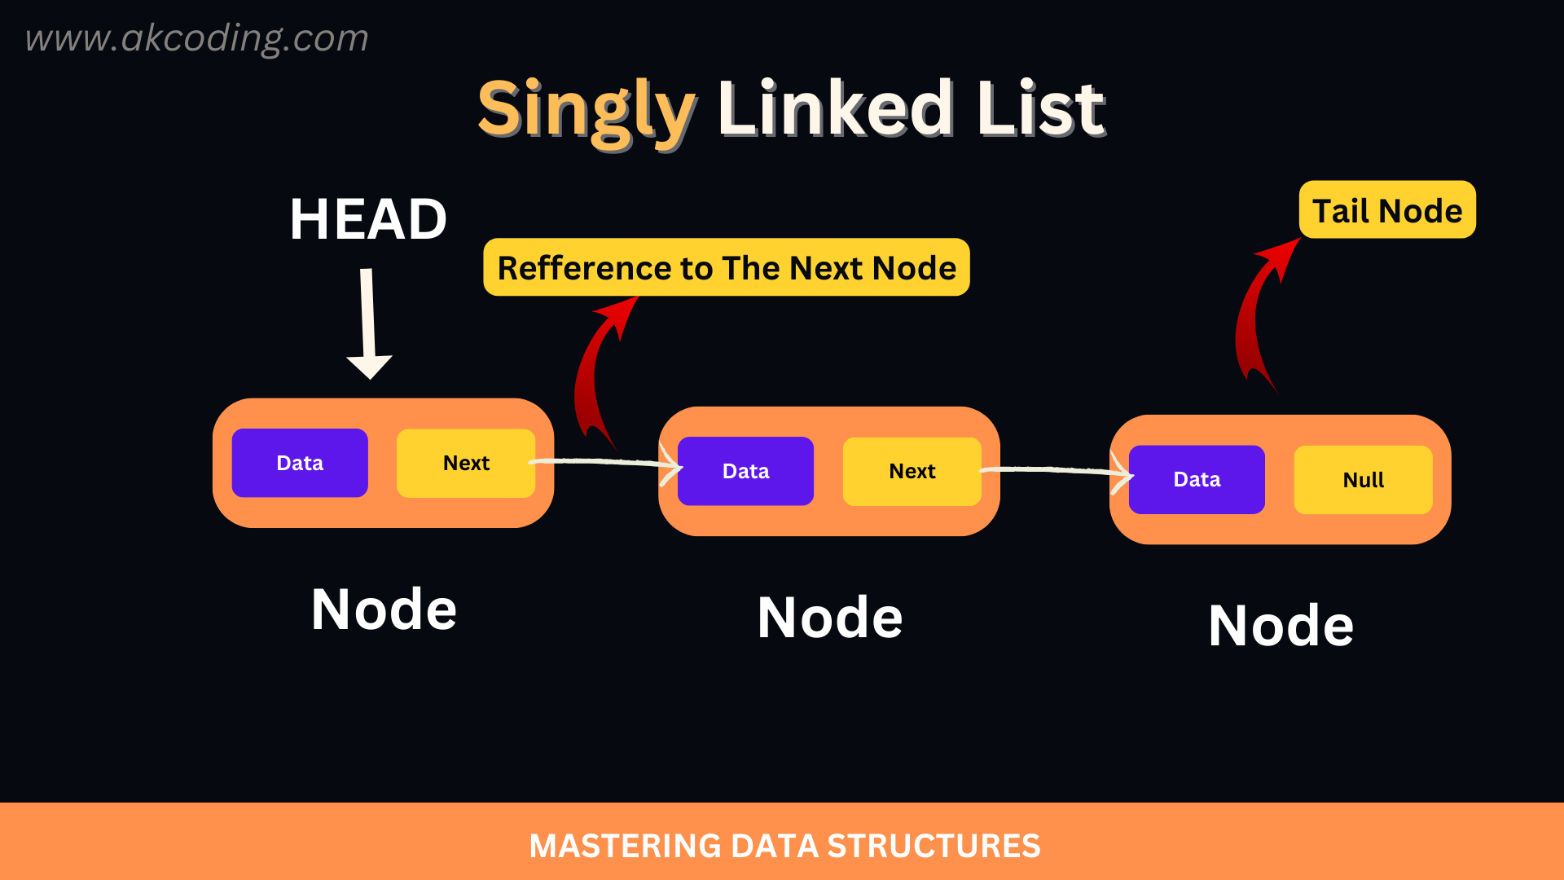
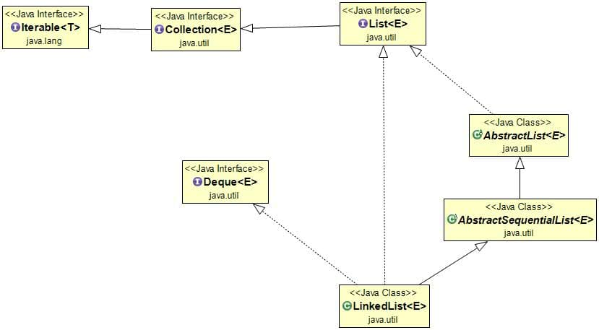
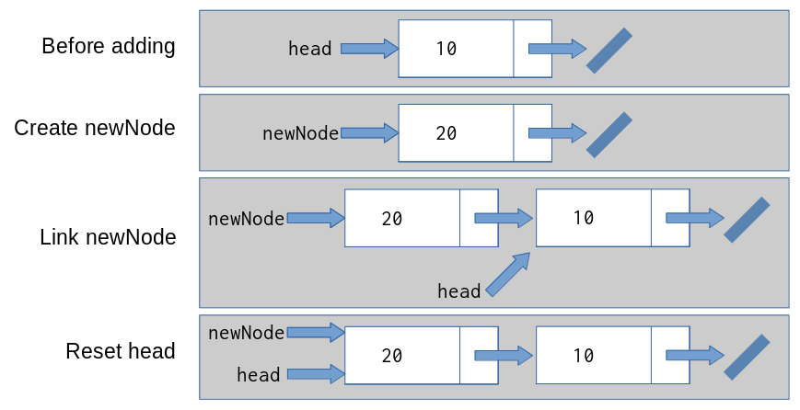

Example
import java.util.*;

public class LinkedListExample {

public static void main(String[] args) {

List<String> cities = new LinkedList<>();

cities.add("Delhi");
cities.add("Mumbai");
cities.add("Bangalore");

cities.addFirst("Chennai");

System.out.println(cities);
}
}

4. Set Interface
A Set stores unique elements only.
Implementations:
- HashSet
- LinkedHashSet
- TreeSet

Set Behavior


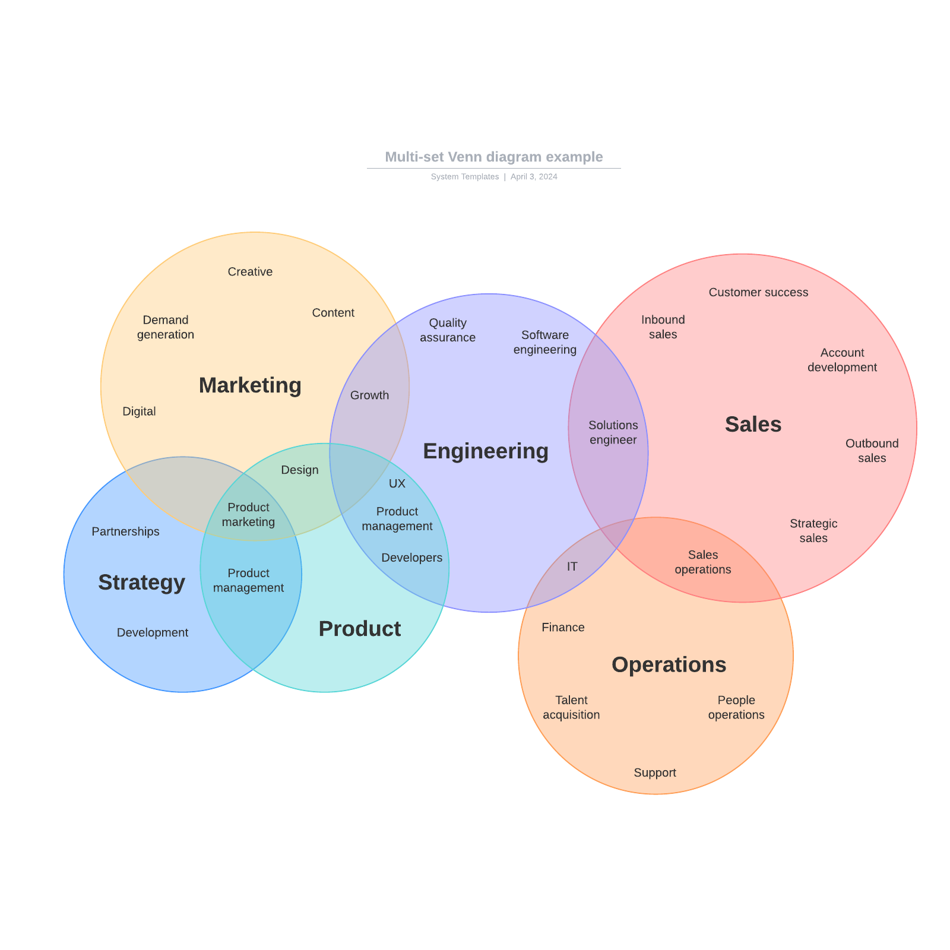
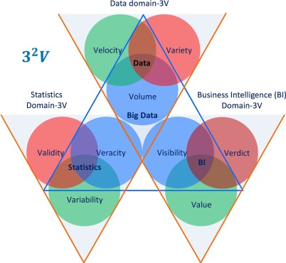

4.1 HashSet
Uses hash table.

Properties
- No duplicates
- Unordered
- Fast lookup

Example
import java.util.*;

public class HashSetExample {

public static void main(String[] args) {

HashSet<Integer> numbers = new HashSet<>();

numbers.add(10);
numbers.add(20);
numbers.add(10);

System.out.println(numbers);
}
}
Output
[10, 20]
Duplicate 10 removed.

4.2 LinkedHashSet
Maintains insertion order.
Example:
LinkedHashSet<String> set = new LinkedHashSet<>();

set.add("A");
set.add("B");
set.add("C");

System.out.println(set);
Output
[A, B, C]

4.3 TreeSet
Uses Red-Black Tree.
Properties:
- Sorted elements
- No duplicates
- Slower than HashSet
Example:
TreeSet<Integer> set = new TreeSet<>();

set.add(40);
set.add(10);
set.add(30);

System.out.println(set);
Output
[10, 30, 40]

5. Queue Interface
A Queue follows FIFO (First In First Out).
Implementations:
- PriorityQueue
- ArrayDeque
- LinkedList

Queue Diagram
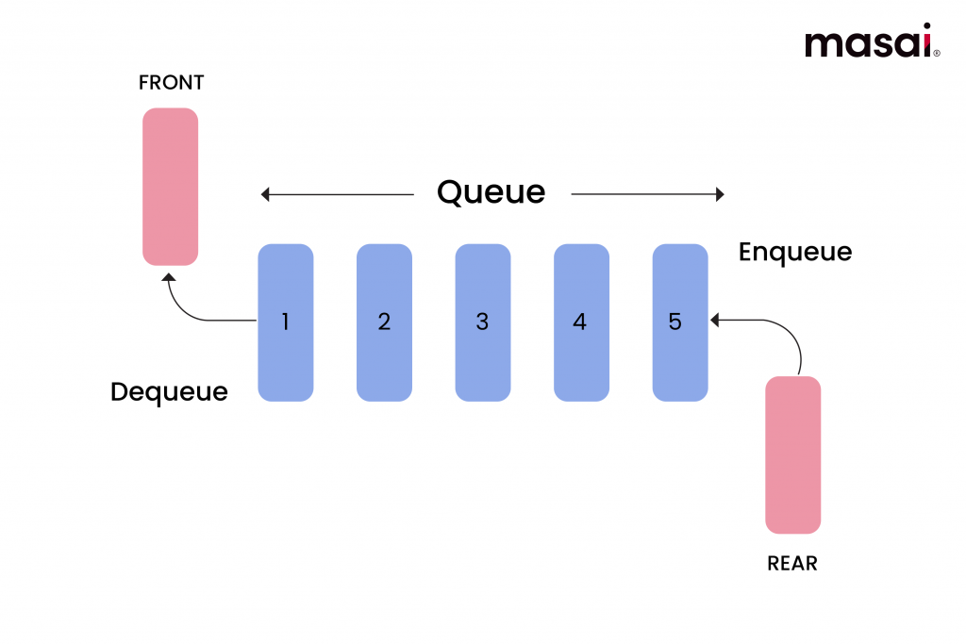
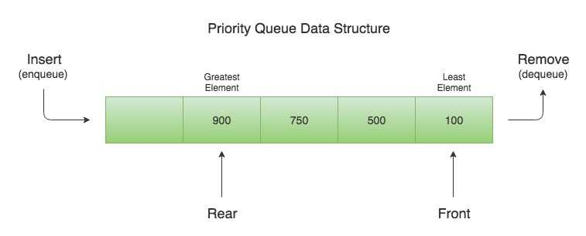

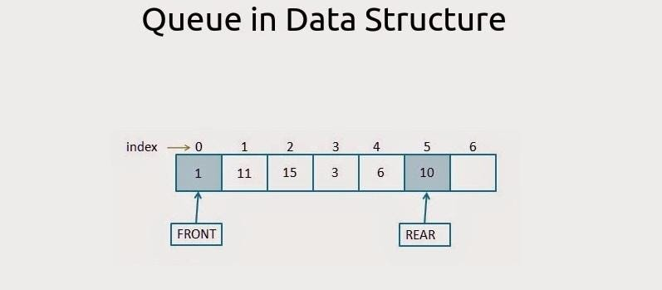

Example: PriorityQueue
import java.util.*;

public class PriorityQueueExample {

public static void main(String[] args) {

PriorityQueue<Integer> pq = new PriorityQueue<>();

pq.add(30);
pq.add(10);
pq.add(20);

System.out.println(pq);

System.out.println(pq.poll());
}
}
Output
[10, 30, 20]
10

6. Map Interface
A Map stores key-value pairs.
Important implementations:
- HashMap
- LinkedHashMap
- TreeMap
- Hashtable

Map Structure
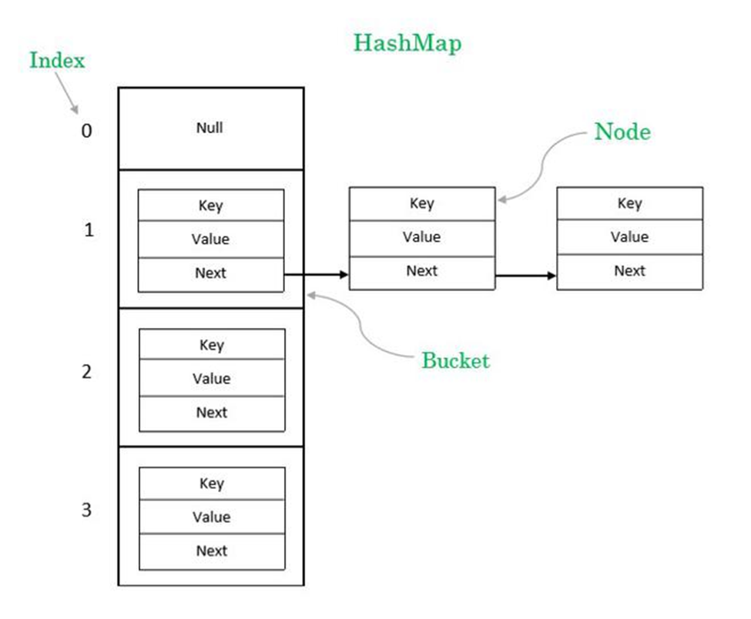

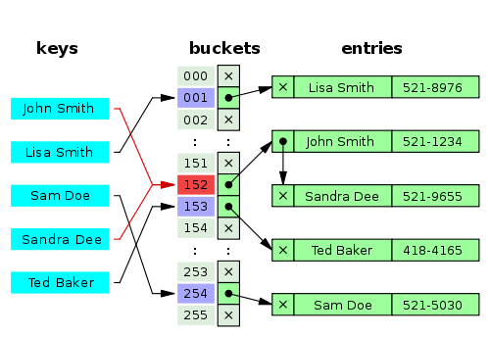
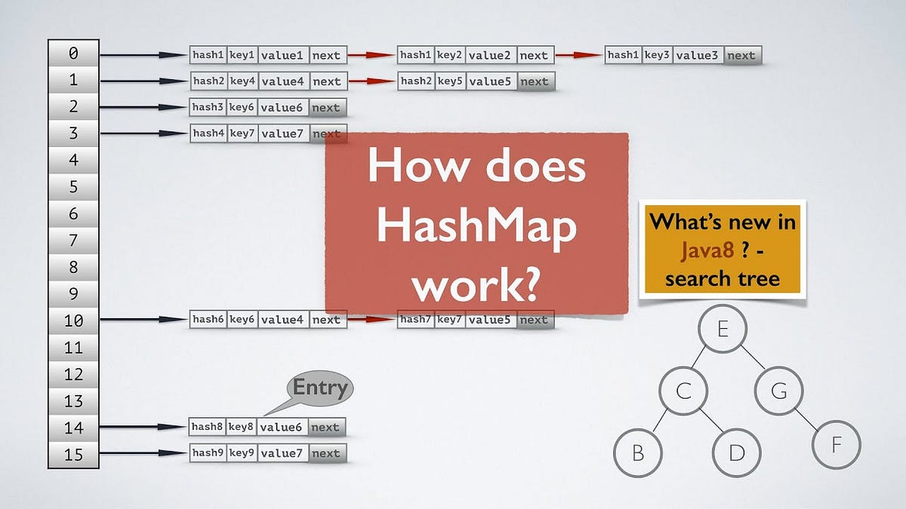

6.1 HashMap
Most widely used map.
Characteristics:
- Key-value storage
- Fast access
- Allows one null key

Example
import java.util.*;

public class HashMapExample {

public static void main(String[] args) {

HashMap<Integer,String> map = new HashMap<>();

map.put(1,"Java");
map.put(2,"Python");
map.put(3,"Go");

System.out.println(map);

System.out.println(map.get(2));
}
}
Output
{1=Java, 2=Python, 3=Go}
Python

6.2 LinkedHashMap
Maintains insertion order.
LinkedHashMap<Integer,String> map = new LinkedHashMap<>();

6.3 TreeMap
Sorted map using Red-Black Tree.
TreeMap<Integer,String> map = new TreeMap<>();
Output automatically sorted.

7. Iterating Collections

Using Iterator
ArrayList<String> list = new ArrayList<>();

list.add("Java");
list.add("Python");

Iterator<String> it = list.iterator();

while(it.hasNext()){
System.out.println(it.next());
}

Using For-Each
for(String s : list){
System.out.println(s);
}

8. Collections Utility Class
Collections provides useful algorithms.
Examples:
Collections.sort(list);
Collections.reverse(list);
Collections.shuffle(list);
Collections.max(list);
Example:
ArrayList<Integer> numbers = new ArrayList<>();

numbers.add(30);
numbers.add(10);
numbers.add(20);

Collections.sort(numbers);

System.out.println(numbers);
Output
[10, 20, 30]

9. Performance Comparison
Collection | Access | Insert | Delete
ArrayList | Fast | Slow middle | Slow middle
LinkedList | Slow | Fast | Fast
HashSet | Fast | Fast | Fast
TreeSet | Medium | Medium | Medium
HashMap | Very Fast | Fast | Fast

10. Real-World Example

Student Management System
import java.util.*;

class Student {

int id;
String name;

Student(int id,String name){
this.id=id;
this.name=name;
}
}

public class StudentExample {

public static void main(String[] args){

ArrayList<Student> students = new ArrayList<>();

students.add(new Student(1,"Rahul"));
students.add(new Student(2,"Anita"));

for(Student s: students){
System.out.println(s.id + " " + s.name);
}
}
}

11. Interview Questions
Common interview questions:
- Difference between ArrayList vs LinkedList
- Difference between HashMap vs Hashtable
- Difference between HashSet vs TreeSet
- What is hashing
- How does HashMap work internally
- What is fail-fast iterator
- Difference between Comparable vs Comparator

